A Comprehensive Review of Text-to-Image Synthesis with GANs

Abstract
This review paper gives an overview of recent Generative Adversarial Network (GAN)-based text-to-image synthesis techniques. The paper discusses the main challenges and applications of text-to-image synthesis, as well as the key components and GAN architectures. The review surveys the most relevant and recent GAN-based models for text-to-image synthesis, including AttnDM-GAN, DMAttn-GAN, DF-GAN, gigaGAN, and GALIP, highlighting their strengths and limitations, and comparing their performance in terms of objective metrics such as FID and IS scores, as well as subjective measures of text-to-image quality.The paper also outlines open challenges and future directions in this area, such as improving the scalability and interpretability of GAN-based models and integrating them with natural language processing and computer vision. The paper also presents a comparative analysis of the GAN-based models for text-to-image synthesis, using objective metrics such as Inception Score (IS) and Fréchet Inception Distance (FID), as well as subjective measures of text-to-image quality. The paper shows that the proposed models, such as DF-GAN, gigaGAN, and GALIP, outperform the existing models, such as AttnGAN, DM-GAN, and MirrorGAN, in terms of generating high-quality and diverse images from textual descriptions. The paper also discusses the limitations and challenges of the current GAN-based methods and suggests some possible future directions for text-to-image synthesis.

Introduction
Text-to-image synthesis also known as image generation from text descriptions is an emerging field in machine learning that involves generating realistic images based on textual descriptions. It involves bridging the gap between language and visual domains by producing realistic images from textual descriptions.With the emergence of generative adversarial networks (GANs), significant progress has been made in the field of text-to-image synthesis.Unlike traditional generative models, GANs have a two-network architecture, which consists of a generator and a discriminator. The generator aims to create realistic images, while the discriminator tries to figure out real and generated images[1]. This adversarial interplay drives the generator to produce increasingly realistic images.
However text-to-image synthesis involves different perspectives and challenges, it includes understanding and modeling the complex relationship between text and images, that require further research efforts including the generation of high-resolution images with multiple objects and creating suitable and reliable evaluation metrics that correlate with human judgment. In this context, researchers have proposed various GAN-based models for text-to-image synthesis, including StackGAN, AttnGAN, MirrorGAN, and DMGAN, among others[2], [3]. This review paper provides an overview of GAN-based methods for text-to-image synthesis, discusses the GAN-based models AttnDM-GAN, DF-GAN, GigaGAN, GALIP, and various challenges and applications of text-to-image synthesis, and presents the key components and architectures of GANs[4]–[8]. Overall, this review provides a comprehensive and up-to-date resource for researchers and practitioners in the field of text-to-image synthesis.

Review of GAN Architectures for Text-to-Image Synthesis
GANs are composed of two competing neural networks: a generator and a discriminator.The two networks are trained together in an adversarial process. The generator tries to create images that are so realistic that the discriminator can't tell them apart from real images. The discriminator, on the other hand, tries to get better at distinguishing between real and fake images.The "Generative Adversarial Text to Image Synthesis" paper, one of the first in this field, suggested a novel deep architecture and GAN implementation to bridge improvements in text and image modeling, translating visual concepts from characters to pixels[9].
Many GAN-based models for text-to-image synthesis have been developed as a result of further research; these models include AttnDM-GAN, DF-GAN, GigaGAN, and GALIP, each with a unique architecture and strategy for overcoming the difficulties of this task.

AttnDM-GAN:
AttnDM-GAN [5] is a multistage architecture model designed for text-to-image synthesis. It is a hybrid model of AttnGAN [10] and DM-GAN [2]. Image generation is achieved in an incremental fashion. The model consists of three stages: attention image generation, dynamic memory-based image refinement and Initial Image Generation.
The first stage generates a low-resolution, simple image that serves as the foundation for subsequent stages. Initial Image Generation stage synthesizes a low-resolution 64x64 image that captures the primitive features and outlines of the image's object based on the input description. This image serves as the foundation for subsequent stages.
The second stage generates the final high-resolution 256×256 image through four components: Memory writing, Key addressing, Value reading and Response. Memory writing component stores the current state of the image in a dynamic memory, Key addressing component retrieves the most relevant information from the memory based on the current input text. Value reading component reads the retrieved information from the memory. Response component generates the final image pixel based on the information from the memory and the current input text.
The third stage synthesizes a low-level 64×64 image that contains the primitive features and the outline of the image's object based on the input description. It is considered the seed image for the final produced image.
AttnDM-GAN, focuses on capturing local details of the text description first, using the attention mechanism. This allows the model to generate images with more accurate and realistic details. Then, it uses the dynamic memory mechanism to capture long-range dependencies and improve the overall structure of the image.

DMAttn-GAN:
DMAttn-GAN[5] Architecture is also a hybrid model of the AttnGAN [10]and the DM-GAN [2], but with a different order of stages. The images are generated in an incremental fashion design. The model is composed of three stages: Initial Image Generation, Dynamic Memory-based Image Refinement and Attention Image Generation.
The first stage initial image generation synthesizes a low-level 64×64 image that contains the primitive features and the outline of the image's object based on the input description. It is considered the seed image for the final produced image.
The second stage dynamic memory-based image refinement generates an improved image with 128×128 pixels using a dynamic memory mechanism. This mechanism allows the model to capture long-range dependencies in the input text description and generate more detailed and realistic images.
The third stage generates the final high-resolution 256×256 image through four components: Memory writing, Key addressing, Value reading and Response. Memory writing component stores the current state of the image in a dynamic memory, Key addressing component retrieves the most relevant information from the memory based on the current input text. Value reading component reads the retrieved information from the memory. Response component generates the final image pixel based on the information from the memory and the current input text.
DMAttn-GAN focuses on capturing long-range dependencies in the text description first, using the dynamic memory mechanism. This allows the model to generate images with more global structure. Then, it uses the attention mechanism to focus on specific parts of the text description and refine the details of the image.DMAttn-GAN is the same as AttnDM-GAN but with switching the second and the third stage.

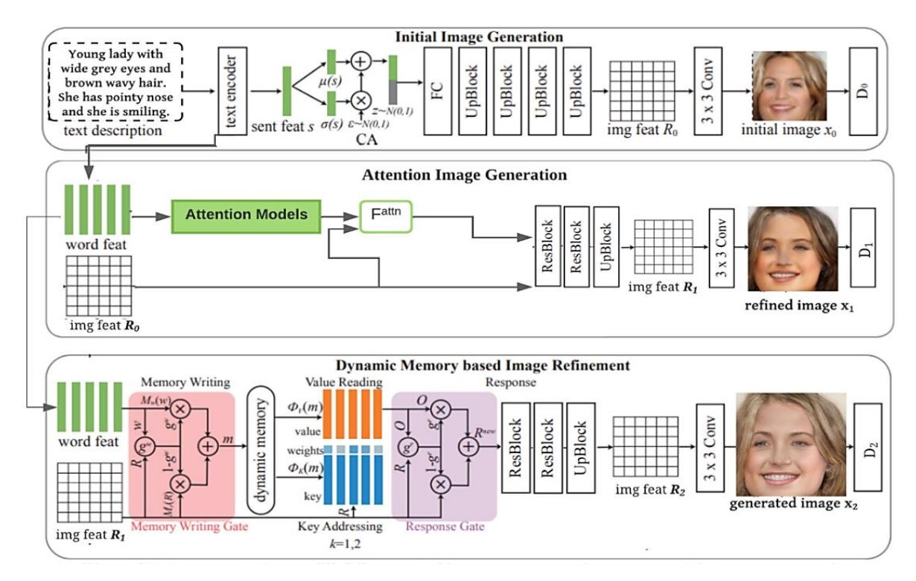
The architecture of model attnDM-GAN for text-to-image synthesis [5].
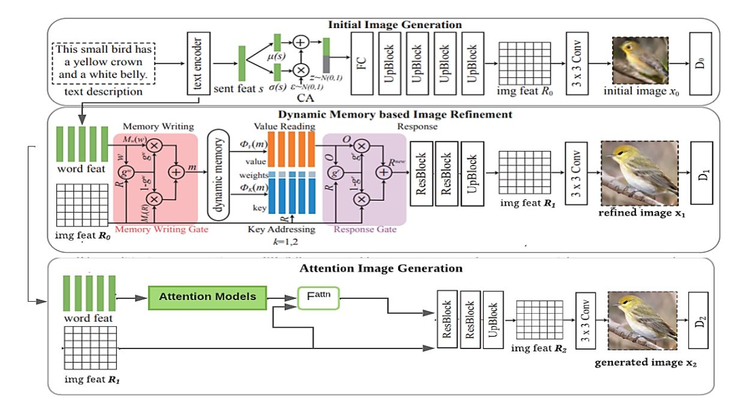
The architecture of model DMAttn-GAN for text-to-image synthesis [5].

DF-GAN:
DF-GAN (Deep Fusion GAN) is a simple and effective model for text-to-image synthesis. DF-GAN employs a one-stage text-to-image backbone that directly synthesizes high-resolution images, eliminating the need for multiple generators and reducing entanglements. DF-GAN consists of a generator, a discriminator, and a pre-trained text encoder.
The one-stage generator takes a sentence vector encoded by the text encoder and a noise vector sampled from a Gaussian distribution as inputs to synthesize high-resolution images directly. The generator uses a series of UPBlocks to upsample the image features, and a novel Deep text-image Fusion Block (DF-Block) to fuse the text and visual features during the image generation process.
A Target-Aware Discriminator converts images into image features through a series of DownBlocks and then replicates and concatenates the sentence vector with the image features to evaluate the visual realism and semantic consistency of the inputs. The proposed Target-Aware Discriminator is composed of Matching-Aware Gradient Penalty (MA-GP) and One-Way Output, which enhances the text-image semantic consistency without introducing extra networks. The One-Way Output allows the single gradient to be pointed directly to the target data points, optimizing and accelerating the convergence of the generator[6].
The Deep text-image Fusion Block (DF-Block) brings two main benefits for text-to-image generation: it allows the generator to more fully exploit the text information when fusing text and image features, and it enlarges the representation space of the fusion module, which is beneficial to generate semantic consistent images from different text descriptions.
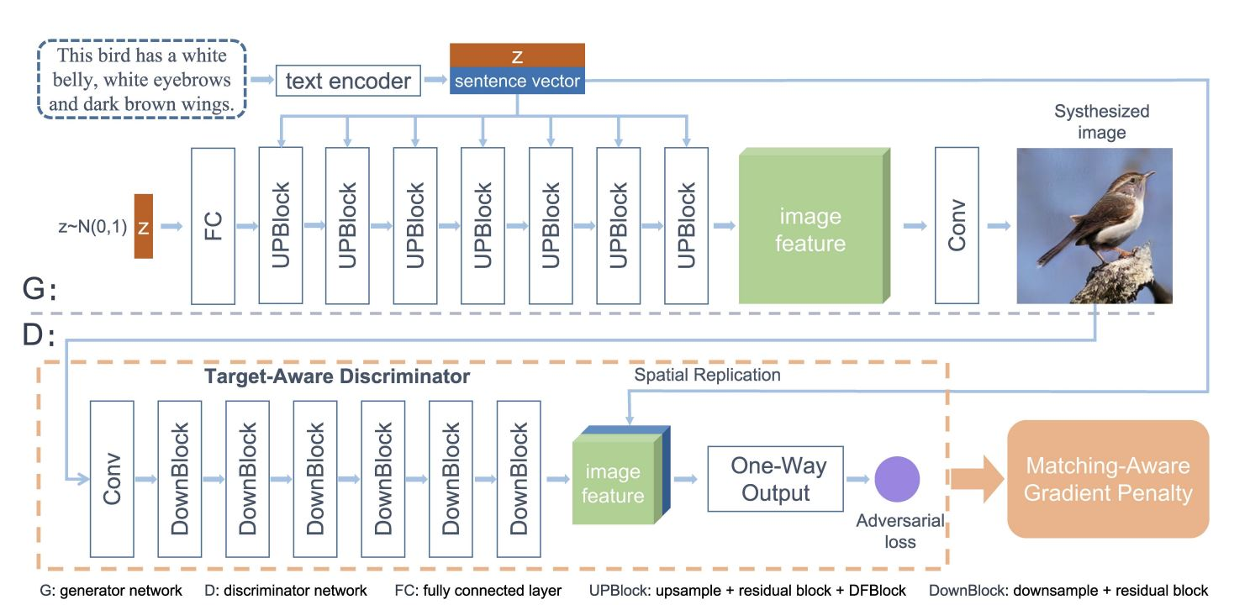
The DF-GAN architecture for text-to-image synthesis [6].

GigaGAN:
GigaGAN architecture is a state-of-the-art model for text-to-image synthesis using Generative Adversarial Networks. The proposed GigaGAN addresses the challenge of open-ended text-conditioned synthesis on internet images by injecting more expressivity into the parameterization. The architecture is based on the conditional version of StyleGAN2, comprised of two networks: the mapping network M that modulates a series of upsampling convolutional layers in the synthesis network Ge(w) to map a learned constant tensor to an output image, and the generator G that predicts an image given a latent code z and text-condition c.
GigaGAN consists of two main components: Text embedding extraction and Style code production.
The generator outputs an image pyramid by converting intermediate features into RGB images using multiple attention and convolution layers at each scale. To handle the diverse distribution of internet images, GigaGAN proposes an efficient way to enhance the expressivity of convolutional kernels by creating them on-the-fly based on the text conditioning. The method shares a spirit with dynamic convolutions in that the convolution filters dynamically change per sample but differs in that a larger filter bank is instantiated and weights are selected based on a separate pathway conditional on the style space of StyleGAN.
The discriminator in GigaGAN consists of two branches for processing the image and the text conditioning. The text branch processes the text similarly to the generator. The image branch receives an image pyramid and makes independent predictions for each image scale, with predictions made at all subsequent scales of the downsampling layers, resulting in a multi-scale input, multi-scale output (MS-I/O) discriminator. Additional CLIP and Vision-Aided GAN losses are introduced to improve stability[4].

GALIP:
GALIP (Generative Adversarial CLIPs) [7] architecture, a novel framework for text-to-image synthesis. The proposed GALIP aims to synthesize high-quality complex images by leveraging the powerful pretrained CLIP model in both the discriminator and generator. The architecture of GALIP consists of a CLIP text encoder, a CLIP-based discriminator, and a CLIP-empowered generator.
The CLIP text encoder takes the text description and yields a global sentence vector T, which is then used by the CLIP-empowered generator and CLIP-based discriminator under the GAN framework. The CLIP-empowered generator comprises a frozen CLIP-ViT and a mate generator (Mate-G), which includes a bridge feature predictor, a prompt predictor, and an image generator. The bridge feature predictor translates the sentence vector and noise to the bridge feature for the CLIP-ViT, and several text-conditioned prompts are added to the transformer blocks in CLIP-ViT for task adaptation. The image generator takes the predicted visual concepts, bridge features, sentences, and noise vectors to synthesize high-quality images.
The CLIP-based discriminator comprises a frozen CLIP-ViT and a mate discriminator (Mate-D), which collects image features from different layers in CLIP-ViT and further extracts informative visual features from collected CLIP features for quality assessment. An adversarial loss is predicted by the quality assessor based on the extracted informative features and sentence vectors. The discriminator promotes the generator to synthesize higher-quality images by distinguishing synthesized images from real ones.
Overall, the GALIP architecture leverages the complex scene understanding ability of CLIP in the discriminator and the domain generalization ability of CLIP in the generator to enable high-quality, efficient, fast, and controllable text-to-image synthesis.

Datasets and Metrics

Model | CUB IS | CUB FID | COCO IS | COCO FID
AttnDM-GAN | 19.78 | 35.056 | 17.04 | 43.815
DMAttn-GAN | 19.76 | 35.082 | 16.98 | 43.921
DF-GAN | 14.81 | 21.41 | 14.12 | 25.67
GigaGAN | 11.32 | 8.52 | 10.08 | 5.85
GALIP | 10.08 | 5.85 | 9.76 | 4.21

Datasets: We compare the performance of the GAN-based models for text-to-image synthesis on two widely used datasets: CUB and COCO. CUB is a fine-grained dataset of bird images with detailed captions, while COCO is a large-scale dataset of diverse images with natural language descriptions.
Metrics: We use two common metrics to evaluate the quality and diversity of the generated images: Inception Score (IS) and Fréchet Inception Distance (FID)1. IS measures how well the generated images match the class labels of the real images, while FID measures the distance between the feature distributions of the real and generated images. Higher IS and lower FID indicate better performance.

Result and Discussion

Model | Architecture | Training Dataset | Quantitative Metrics (e.g., IS, FID) | Qualitative Assessment
AttnDM-GAN | Cross-modal attention mechanism | CUB  CelebAText | 19.78  35.056 | Consistency with textual data
DMAttn-GAN | Cross-modal attention mechanism | CUB  CelebAText | 17.04  43.815 | Realism and  consistency
DF-GAN | One-stage text-to-image backbone | CUB  COCO | 14.81  21.41 | Realistic and text-matching images
GALIP | CLIP-ViT and Mask R-CNN integration | CUB  COCO | 10.08  5.85 | Controllable blending images

The review of various GAN-based models for text-to-image synthesis, including AttnDM-GAN, DMAttn-GAN, DF-GAN, gigaGAN, and GALIP, reveals the significant advancements in this field. These models have been evaluated based on quantitative measures such as Inception Score (IS) and Fréchet Inception Distance (FID), as well as qualitative assessments of the generated images.
DF-GAN, a novel Deep Fusion Generative Adversarial Network, has demonstrated competitive performance, achieving a reduction in FID compared to AttnGAN and DM-GAN. The proposed model synthesizes high-quality images directly and incorporates a Target-Aware Discriminator to enhance text-image semantic consistency.
The gigaGAN architecture, has shown promising results in generating high-quality images from textual descriptions, enhances the model's ability to understand and interpret the textual input, leading to the generation of more accurate and realistic images.
The GALIP framework, which leverages Generative Adversarial CLIPs for text-to-image synthesis, represents a significant advancement in the field.
Overall, the review of these GAN-based models for text-to-image synthesis highlights the significant progress in this field, with the proposed architectures demonstrating the ability to generate high-quality and diverse images from textual descriptions. The integration of advanced techniques such as gigaGAN, and CLIP has further improved the performance of these models, offering promising solutions for various applications that require the generation of visual content from textual descriptions.

Conclusion
Text-to-image synthesis is a challenging and fascinating task that involves generating realistic and diverse images from textual descriptions1. This review paper has provided an overview of the recent GAN-based models for text-to-image synthesis, such as AttnDM-GAN, DF-GAN, GigaGAN, and GALIP, highlighting their main components, architectures, and performance23. The paper has also discussed the applications and challenges of text-to-image synthesis, such as improving the scalability, interpretability, and evaluation of the models4. The paper has shown that text-to-image synthesis is a promising and active research area, with many opportunities for future work and innovation.

References
[1] M. Berrahal and M. Azizi, “Optimal text-to-image synthesis model for generating portrait images using generative adversarial network techniques,” Indones. J. Electr. Eng. Comput. Sci., vol. 25, no. 2, p. 972, Feb. 2022, doi: 10.11591/ijeecs.v25.i2.pp972-979.
[2] M. Zhu, P. Pan, W. Chen, and Y. Yang, “DM-GAN: Dynamic Memory Generative Adversarial Networks for Text-To-Image Synthesis,” in 2019 IEEE/CVF Conference on Computer Vision and Pattern Recognition (CVPR), Long Beach, CA, USA: IEEE, Jun. 2019, pp. 5795–5803. doi: 10.1109/CVPR.2019.00595.
[3] T. Qiao, J. Zhang, D. Xu, and D. Tao, “MirrorGAN: Learning Text-To-Image Generation by Redescription,” in 2019 IEEE/CVF Conference on Computer Vision and Pattern Recognition (CVPR), Jun. 2019, pp. 1505–1514. doi: 10.1109/CVPR.2019.00160.
[4] M. Kang et al., “Scaling up GANs for Text-to-Image Synthesis,” in 2023 IEEE/CVF Conference on Computer Vision and Pattern Recognition (CVPR), Vancouver, BC, Canada: IEEE, Jun. 2023, pp. 10124–10134. doi: 10.1109/CVPR52729.2023.00976.
[5] R. Bayoumi, M. Alfonse, M. Roushdy, and A.-B. M. Salem, “Text-to-image generation based on AttnDM-GAN and DMAttn-GAN: applications and challenges,” Bull. Electr. Eng. Inform., vol. 12, no. 2, pp. 1180–1188, Apr. 2023, doi: 10.11591/eei.v12i2.4199.
[6] M. Tao, H. Tang, F. Wu, X. Jing, B.-K. Bao, and C. Xu, “DF-GAN: A Simple and Effective Baseline for Text-to-Image Synthesis,” in 2022 IEEE/CVF Conference on Computer Vision and Pattern Recognition (CVPR), New Orleans, LA, USA: IEEE, Jun. 2022, pp. 16494–16504. doi: 10.1109/CVPR52688.2022.01602.
[7] M. Tao, B.-K. Bao, H. Tang, and C. Xu, “GALIP: Generative Adversarial CLIPs for Text-to-Image Synthesis,” in 2023 IEEE/CVF Conference on Computer Vision and Pattern Recognition (CVPR), Vancouver, BC, Canada: IEEE, Jun. 2023, pp. 14214–14223. doi: 10.1109/CVPR52729.2023.01366.
[8] M. Siddharth and R. Aarthi, “Blended multi-class text to image synthesis GANs with RoBerTa and Mask R-CNN,” Procedia Comput. Sci., vol. 218, pp. 845–857, 2023, doi: 10.1016/j.procs.2023.01.065.
[9] S. Reed, Z. Akata, X. Yan, L. Logeswaran, B. Schiele, and H. Lee, “Generative Adversarial Text to Image Synthesis.” arXiv, Jun. 05, 2016. doi: 10.48550/arXiv.1605.05396.
[10] T. Xu et al., “AttnGAN: Fine-Grained Text to Image Generation with Attentional Generative Adversarial Networks.” arXiv, Nov. 28, 2017. doi: 10.48550/arXiv.1711.10485.

